**Revisiting the Playbook created**

* [Refer](https://raw.githubusercontent.com/asquarezone/AnsibleZone/master/May21/spring-boot-deployment/spc-deploy.yaml) below for the playbook created

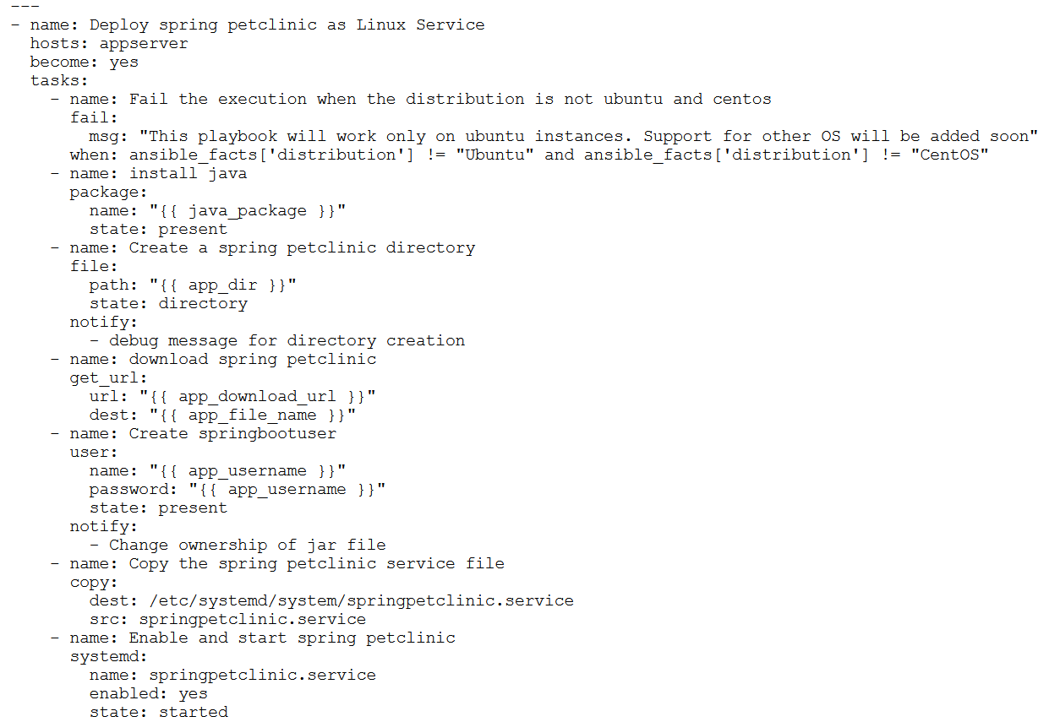

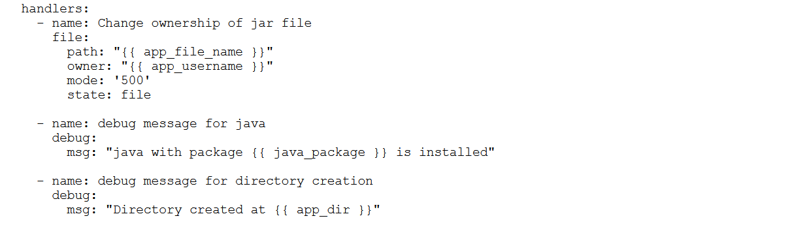

* Added *vars* section in the playbook to define variables

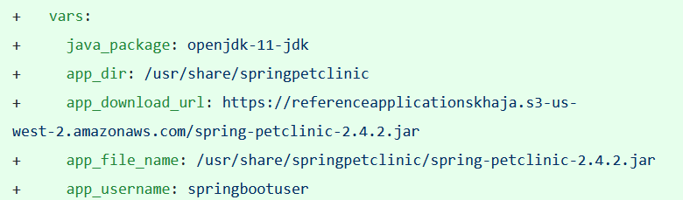

* Create a change set for testing variables

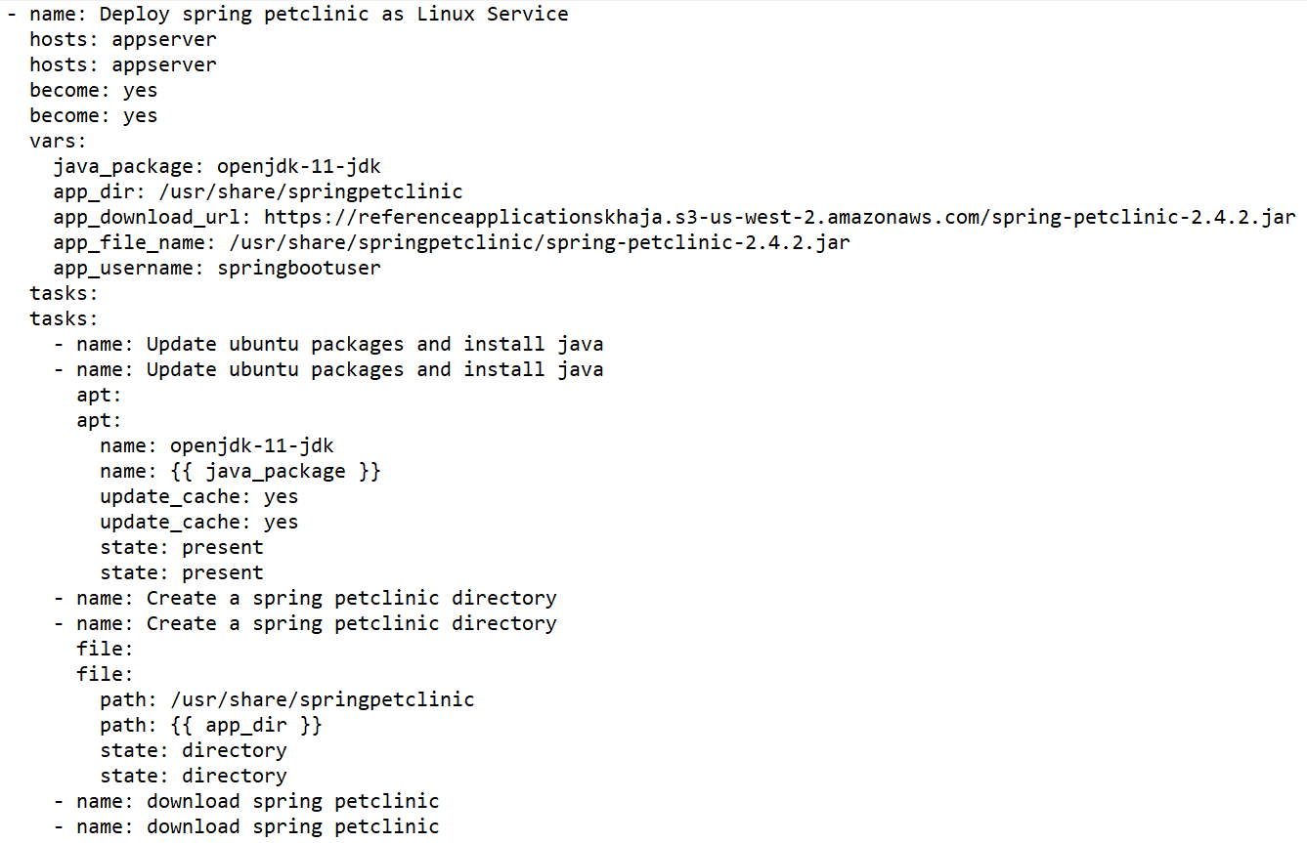

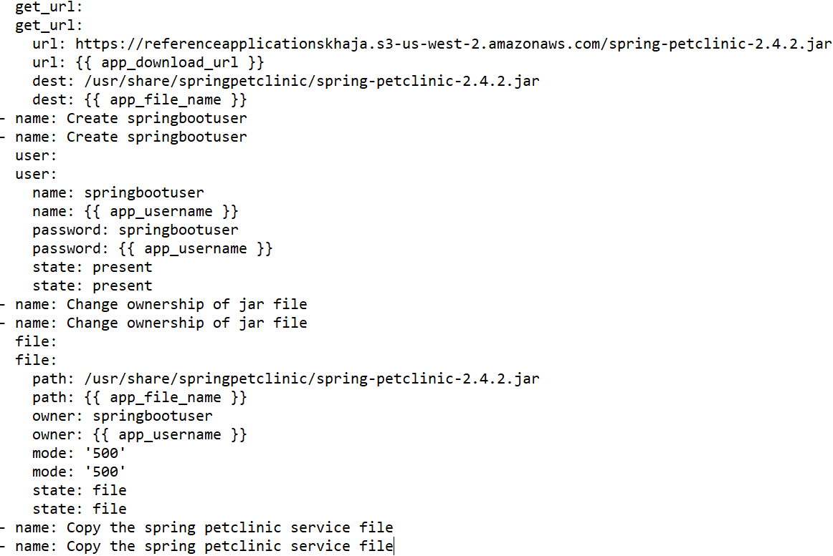

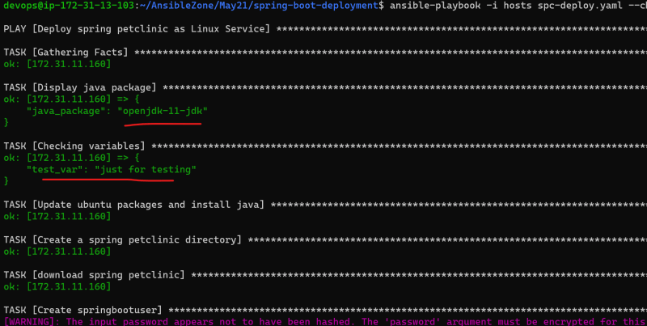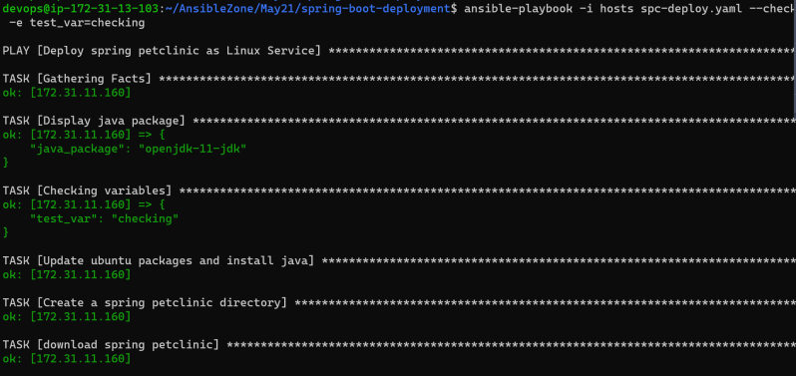

* Ansible variables can be defined at multiple places and they have some priority which is referred as precedence
* At this moment lets try to understand about ansible inventories
* In Ansible there is a default inventory located at /etc/ansible/hosts and if we don’t pass the -i to ansible-playbook or ansible command the inventory file considered would be the default inventory

**Creating Inventories**

* Inventories can be created in two formats in ansible
  + INI: (<https://en.wikipedia.org/wiki/INI_file>)
  + YAML
* Sample INI based inventory 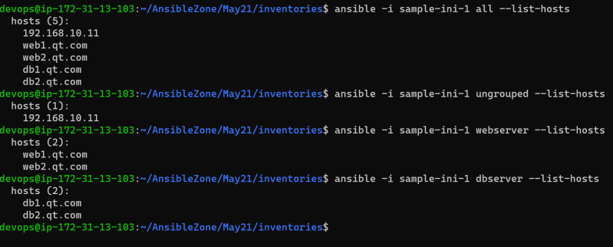
* Sample YAML Based inventory 